SWE 303 – Testing & QA
Thomas Kroj SWE 3B

Testing analysis
1) Boundary Value Testing (BVT)
PricingService.calculateBasePrice(double dailyRate, long days)
Behavior (from code): basePrice = dailyRate * days (no internal validation).
Valid input rules (from project context):
- dailyRate is validated as positive in CarService (Validators.isPositive(dailyRate) ⇒ dailyRate > 0).
- days comes from DateRange.getDays() which is inclusive and ≥ 1 (constructor prevents end < start).
Input Domains Used for BVT
- dailyRate: (0, +∞)
- days: [1, +∞)
Since there is no max defined in code, BVT focuses on the lower boundaries + representative “large” values.
BVT Table (dailyRate boundary, keep days = 1)
Test ID | dailyRate | days | Expected basePrice | Notes
BVT-DR-1 | -1.0 | 1 | -1.0 | Below valid range (should be invalid by business rules; multiplication still returns value)
BVT-DR-2 | 0.0 | 1 | 0.0 | Boundary at 0 (invalid by business rule: must be > 0)
BVT-DR-3 | 0.01 | 1 | 0.01 | Smallest “valid” representative positive value
BVT-DR-4 | 100.0 | 1 | 100.0 | Typical valid value
BVT-DR-5 | 1000000.0 | 1 | 1000000.0 | Large value / stress boundary (still valid)

BVT Table (days boundary, keep dailyRate = 10.0)
Test ID | dailyRate | days | Expected basePrice | Notes
BVT-D-1 | 10.0 | 0 | 0.0 | Below minimum (invalid by DateRange rules; if passed directly, multiplication gives 0)
BVT-D-2 | 10.0 | 1 | 10.0 | Minimum valid boundary
BVT-D-3 | 10.0 | 2 | 20.0 | Min + 1
BVT-D-4 | 10.0 | 7 | 70.0 | Typical valid (1 week)
BVT-D-5 | 10.0 | 365 | 3650.0 | Large representative rental period
Short note: This method does not enforce validation internally; business constraints for dailyRate and days are enforced by CarService and DateRange.

2) Equivalence Class Testing / Decision Table — AdminController.validateWorkerInputs
Signature:
validateWorkerInputs(String username, String password, String firstName, String lastName, String email, String phone, String employeeId, String department)
Behavior: Returns true only if all validations pass; otherwise shows a validation message and returns false.
Validation Rules (from code + Validators)
- username: Validators.isNotEmpty (not null, trim not empty)
- password: Validators.isValidPassword (not null AND length ≥ 6)
- firstName, lastName: both isNotEmpty (AND condition overall: fails if either empty)
- email: Validators.isValidEmail (matches regex, not null/empty)
- phone: Validators.isValidPhone (spaces/dashes removed, must be 10–15 digits)
- employeeId: isNotEmpty
- department: isNotEmpty

Equivalence Classes (per input)
Field | Valid Class | Invalid Classes (examples) | Expected Result
username | non-null, trim length ≥ 1 (e.g., "john") | null, "", " " | false (Username required)
password | non-null, length ≥ 6 (e.g., "secret1") | null, "", length 1–5 (e.g., "12345") | false (Password ≥ 6)
firstName | non-null, trim length ≥ 1 | null, "", " " | false (First/Last required)
lastName | non-null, trim length ≥ 1 | null, "", " " | false (First/Last required)
email | matches ^[A-Za-z0-9+_.-]+@[A-Za-z0-9.-]+\\.[A-Za-z]{2,}$ (e.g., a@b.com) | null, "", "abc", "a@b", "a@b." | false (Valid email)
phone | after removing spaces/dashes, 10–15 digits (e.g., "0691234567", "069-123-4567") | null, "", <10 digits, >15 digits, contains letters | false (Valid phone 10–15 digits)
employeeId | non-null, trim length ≥ 1 | null, "", " " | false (Employee ID required)
department | non-null, trim length ≥ 1 | null, "", " " | false (Department required)

Minimal Equivalence-Class Test Set (one “all valid” + one invalid per rule)
Test ID | What is invalid? | Example Inputs (only key field shown) | Expected
EC-0 | none | all fields valid | true
EC-1 | username | username="" | false
EC-2 | password | password="12345" | false
EC-3 | first/last | firstName="" OR lastName="" | false
EC-4 | email | email="abc" | false
EC-5 | phone | phone="123" | false
EC-6 | employeeId | employeeId=" " | false
EC-7 | department | department=null | false
(Note: method returns on the first failing rule, so each test isolates one invalid field while keeping earlier fields valid.)

3) Code Coverage & MC/DC — LoginController.handleLogin
Method: private void handleLogin()
Main decisions/branches:
- if (username.isEmpty() || password.isEmpty()) → validation error + return
- try { userOpt = authService.login(...) }
- if (userOpt.isPresent()) → success path (welcome, clear password, goToHome)
- else → login failed path (error, clear password)
- catch (Exception e) → login error path
Coverage Targets
- Statement coverage: execute every statement at least once
- Branch coverage: take both outcomes of decision (1) and (3), plus catch path
- Condition coverage: make each atomic condition in (1) evaluate both true and false
- MC/DC: for decision (1), show each condition independently affects outcome
Conditions for MC/DC
Decision D1: C1 OR C2
- C1: username.isEmpty()
- C2: password.isEmpty()

Minimal Test Set (covers Statement + Branch + Condition + MC/DC)
Test ID | username | password | authService.login result | Expected path / outcome
COV-1 | "" | "x" | not called | Triggers D1 = true (C1 true). Shows validation error, returns
COV-2 | "user" | "" | not called | Triggers D1 = true (C2 true). Shows validation error, returns
COV-3 | "user" | "pass" | Optional.of(account) | D1 = false; user present → success message, password cleared, goToHome() called
COV-4 | "user" | "pass" | Optional.empty() | D1 = false; user not present → “Login Failed”, password cleared
COV-5 | "user" | "pass" | throws Exception | D1 = false; catch executes → “Login Error …”

MC/DC Proof (for D1 = C1 OR C2)
Pair | C1 (username empty) | C2 (password empty) | D1 outcome | Shows independent effect?
COV-3 vs COV-1 | false → true | false | false → true | Yes (C1 toggles outcome)
COV-3 vs COV-2 | false | false → true | false → true | Yes (C2 toggles outcome)
Branch coverage achieved:
- D1: true (COV-1, COV-2), false (COV-3/4/5)
- userOpt.isPresent: true (COV-3), false (COV-4)
- exception branch: taken (COV-5)

Testing
NOTE: All tests were run individually, otherwise popups would “fight” to be ran by JavaFx, causing faliures
A) PricingService.calculateBasePrice — Test table
Test cases table
Method: double calculateBasePrice(double dailyRate, long days)
Behavior in code: return dailyRate * days;
Test ID | dailyRate | days | Expected | Reason
PS-1 | 10.0 | 1 | 10.0 | normal case
PS-2 | 10.0 | 0 | 0.0 | boundary on days (0)
PS-3 | 0.0 | 5 | 0.0 | boundary on dailyRate (0)
PS-4 | -10.0 | 2 | -20.0 | negative rate (method doesn’t validate)
PS-5 | 12.5 | 4 | 50.0 | Decimals
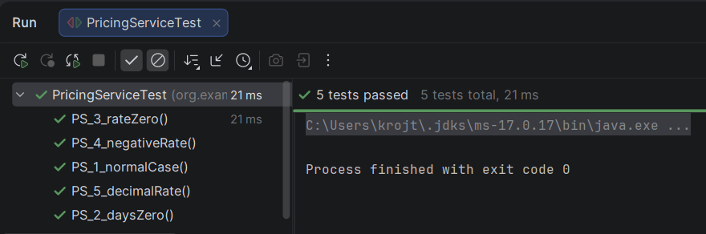

B) AdminController.validateWorkerInputs — Test table + JUnit
Key issue: it shows dialogs (would freeze tests)
So we mock static Dialogs to avoid real Alert.showAndWait().
Also method is private, so we invoke via reflection.
Test cases table
Method: private boolean validateWorkerInputs(...)
Test ID | What input is invalid? | Example | Expected | Reason
ADM-0 | none | all valid fields | true | happy path
ADM-1 | username empty | "" | false | username required
ADM-2 | password too short | "12345" | false | min length 6
ADM-3 | first name empty | "" | false | first+last required
ADM-4 | email invalid | "abc" | false | must match email format
ADM-5 | phone invalid | "123" | false | must be 10–15 digits
ADM-6 | employeeId empty | " " | false | employeeId required
ADM-7 | department empty | null | false | department required
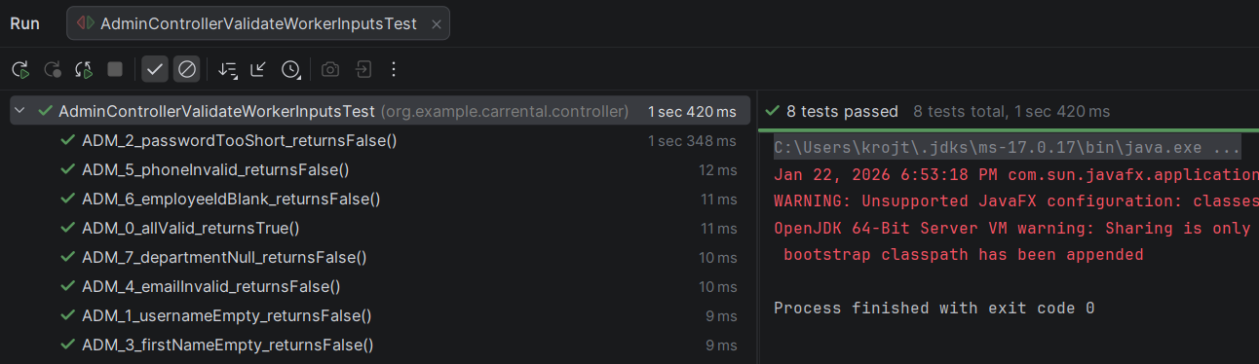
- errors on the right are javafx issues, not code/test issues

C) LoginController.handleLogin — Test table
Issues:
- handleLogin() is private → reflection
- It calls Dialogs.* → must mock static
- Success path calls goToHome() which uses AppNavigator and needs a Stage → we init AppNavigator in tests

Test cases table (paste into Word)
Method: private void handleLogin()
Test ID | username | password | authService.login result | Expected | Reason
LOG-1 | "" | x | not called | validation error | username empty
LOG-2 | user | "" | not called | validation error | password empty
LOG-3 | user | pass | Optional.of(Account) | success dialog + password cleared | success branch
LOG-4 | user | pass | Optional.empty() | error dialog + password cleared | invalid creds
LOG-5 | user | pass | throws Exception | error dialog | exception path

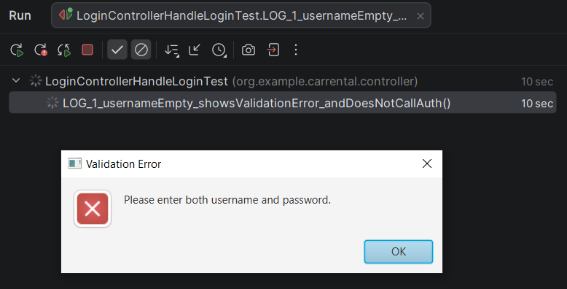 | 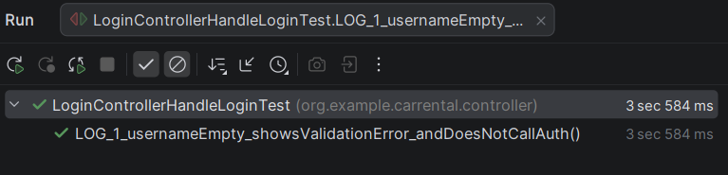
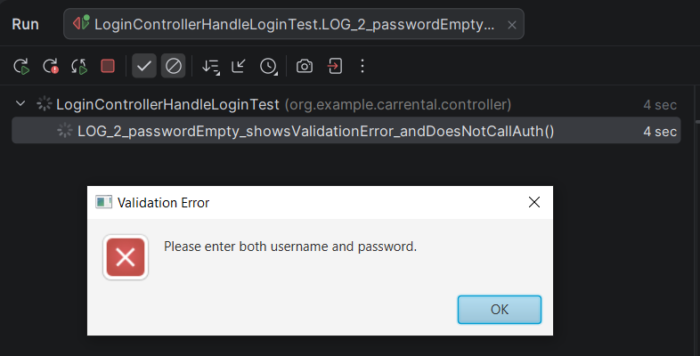 | 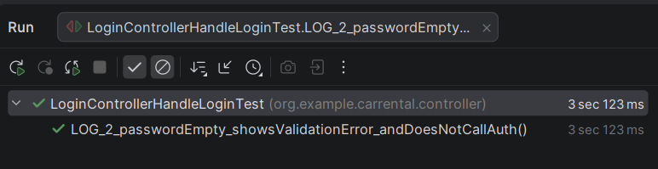
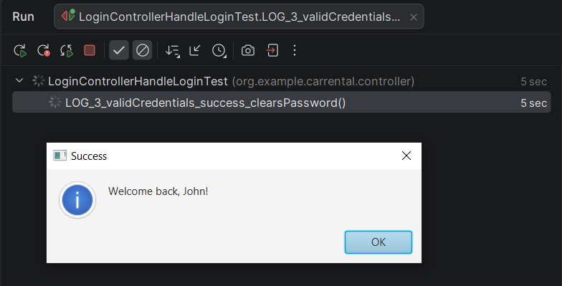 | 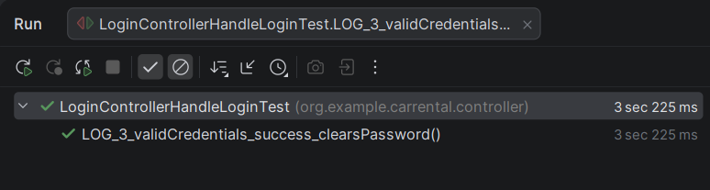
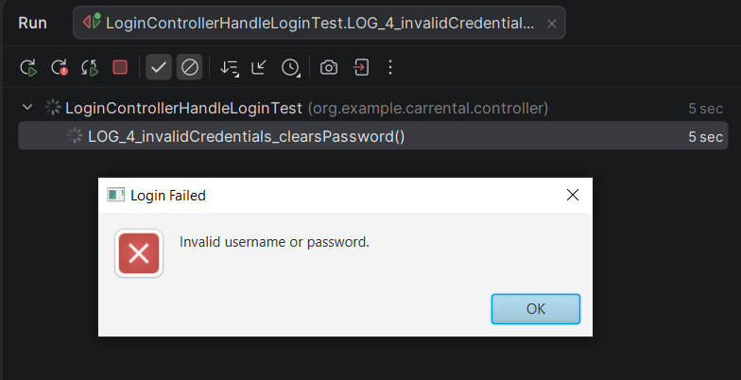 | 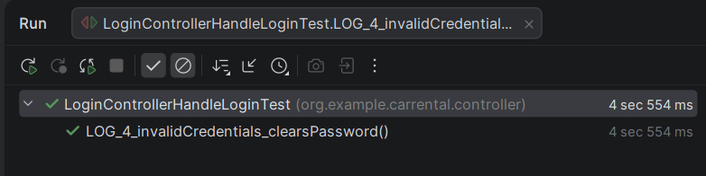
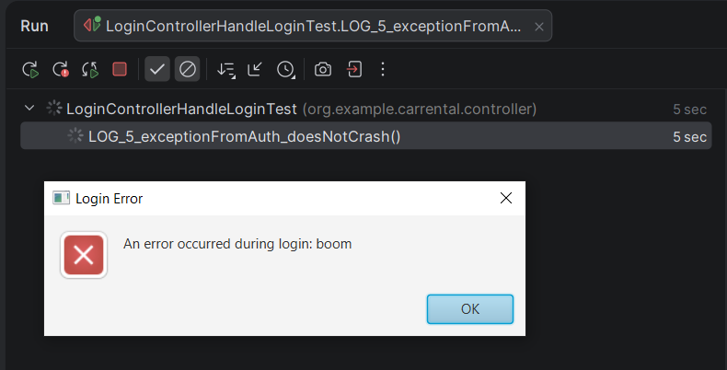 | 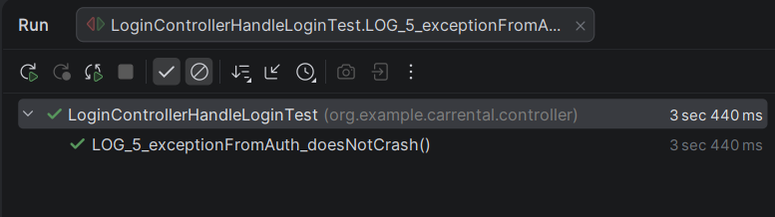

- runtime differs between screenshots because it times out during the time it takes me to screenshot it (causing the test to fail) and I have to run it again, pressing OK the second time (leading to a pass)
UNIT TESTS
UT1 — Validators.isValidEmail(email)
Unit Test Table
Test ID | Target | Input | Expected Output | Type
UT-VAL-01 | Validators.isValidEmail(null) | null | returns false | Unit
UT-VAL-02 | Validators.isValidEmail(" ") | blank | returns false | Unit
UT-VAL-03 | Validators.isValidEmail("user@test.com") | valid email | returns true | Unit
UT-VAL-04 | Validators.isValidEmail("invalid-email") | missing @/domain | returns false | Unit
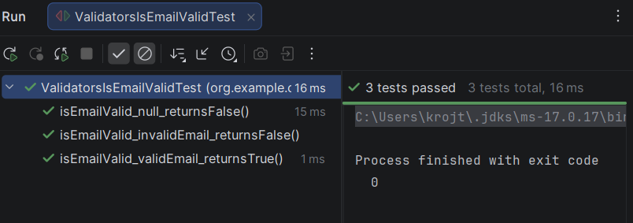

UT2 – Validators.isNotEmpty(Value)
Test Cases Table
Test Case ID | Input Value | Expected Output | Actual Result | Reason for Test Case | Test Type | Responsible
UT-1 | "John" | true | PASS | Valid non-empty string should be accepted | Unit | Thomas Kroj
UT-2 | " " | false | PASS | Blank string should be rejected | Unit | Thomas Kroj
UT-3 | null | false | PASS | Null input should be rejected | Unit | Thomas Kroj

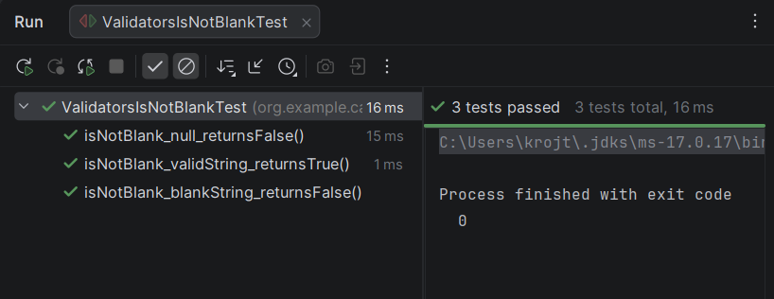

UT3 - CarService.searchCars(query)
Unit Test Table
Test ID | Target | Input | Expected Output | Type
UT-CAR-01 | CarService.searchCars(null) | null | returns carRepository.findAll() | Unit
UT-CAR-02 | CarService.searchCars(" ") | blank | returns carRepository.findAll() | Unit
UT-CAR-03 | CarService.searchCars(" bmW ") | spaced | calls carRepository.search("bmW") and returns it | Unit
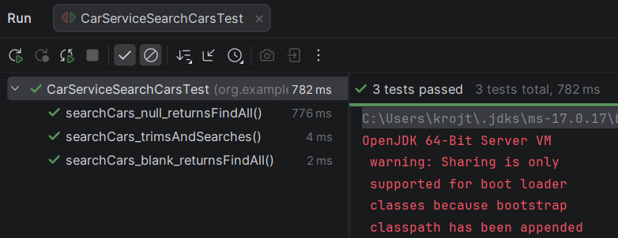

INTEGRATION TESTS
Integration Test Table
Test ID | Scenario | Components involved | Steps | Expected Result | Type
IT-01 | Create booking generates invoice | BookingService + CarService + PricingService + InvoiceService + BookingRepository | 1) Choose an available car. 2) Call BookingService.createBooking(carId, dateRange, user) 3) Check booking saved and updated with invoiceId | Booking created, stored, invoice created, booking updated with invoiceId | Integration
IT-02 | Cancelling booking updates status | BookingService + BookingRepository | 1) Create/save a CONFIRMED booking 2) Call cancelBooking(bookingId) 3) Read booking again | Status becomes CANCELLED and repository update called | Integration
IT-03 | Register end-user persists new user | AuthService + Validators + HashUtil + UserRepository | 1) Call registerEndUser(...) with valid values 2) Search repo by username/email | Returns true, and user exists in repository afterward | Integration

SYSTEM TESTS (end-to-end app scenarios)
System Test Table
Test ID | Scenario | Steps | Expected Result | Type
ST-01 | Customer signup → login | 1) Open app 2) Signup with valid data 3) Login with same credentials | Signup success, then login success, session becomes logged-in | System
ST-02 | Customer books a car → invoice exists | 1) Login as customer 2) Browse cars 3) Select available car + date range 4) Confirm booking 5) Open invoice | Booking confirmed, invoice generated and can be read via invoice screen/content | System
ST-03 | Admin manages cars | 1) Login as admin 2) Add a car (valid fields) 3) Verify it appears in car list 4) Remove the car 5) Verify it disappears | Add and remove operations reflected correctly in UI and stored data | System

